**Bloat Surgery/ Gastric Dilatation and Volvulus (GDV)**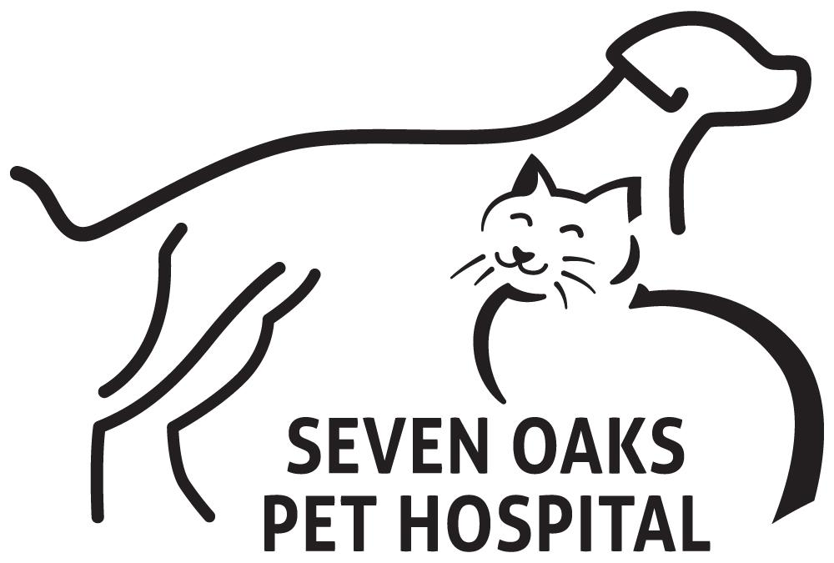

**Gastric Dilatation and Volvulus Syndrome (GDV) or Bloat**

**Gastric dilatation and volvulus syndrome (GDV)**, known as **bloat**, occurs in dogs when the stomach dilates and twists into an abnormal position, causing nonproductive retching, a bloated abdomen, and other symptoms. GDV is a serious, life-threatening condition that requires emergency treatment. Without prompt medical attention, dogs with bloat can die very quickly; about 30% of dogs that suffer bloat die from it.

**Gastric Dilatation:**When the stomach dilates and maintains its normal position, the condition is known as **gastric dilatation**. Gastric dilatation can occur in any dog, and is quite common among young puppies that overeat.

Dogs are usually able to relieve the built-up pressure in their stomachs by vomiting or by belching. When belching and vomiting don't provide relief, emergency treatment similar to that for GDV may be necessary. It may be difficult to determine whether a dog is experiencing simple dilatation, or dilatation and volvulus until **x-rays of the stomach** are taken. Pet owners should be cautious if their dog experiences bouts of gastric dilatation.

**Gastric Dilatation and Volvulus(GDV):**In gastric dilatation and volvulus, the stomach rolls, or twists, closing off the openings leading in from the esophagus and out to the intestines. This prevents the dog from vomiting or belching (one of the most common symptoms of GDV is **nonproductive retching**). Sometimes the word *torsion* is used to describe the twisting. Torsion prevents outflow from the stomach by closing off the pylorus, the opening from the stomach to the duodenum.

If the stomach twists enough, the spleen and major blood vessels in the area twist as well. Twisted blood vessels cause a loss of blood flow (ischemia) to the stomach and other abdominal organs which can cause considerable **tissue damage**. When blood flow returns, the damaged cellular material from the traumatized tissues is released into the blood and can be harmful to other organs.

When the blood supply in the abdomen's major arteries is cut off, blood flow to the heart and cardiac ouput decrease, leading to low blood pressure, and eventually, shock. **Shock** occurs when organs do not get enough blood, and it is usually severe.

In some cases, the stomach **ruptures** from the buildup of pressure and leads to life-threatening **peritonitis** (inflammation of the peritoneum, the membrane that lines the abdominal cavity).

**Risk Factors for Bloat:**

**Bloat can occur in any do**g, but it's more common in large, deep-chested breeds such as:

* Akita
* Great Dane
* Bouvier
* Irish Setter
* Boxer
* Labrador Retriever
* Doberman Pinscher
* St. Bernard
* English Sheepdog
* Standard Poodle
* German Shepherd
* Wolfhound
* Golden Retriever

**Dietary risk factors include the following:**

* Drinking large amounts of water immediately after eating
* Eating a single, large meal daily
* Eating from a raised feeding bowl (In one study, about half of the dogs with GDV had a history of eating from a raised feeding bowl.)
* Exercising vigorously on a full stomach
* Gulping down food very quickly

GDV has been associated with **increasing age** and having a **first-degree relative** with a history of GDV.

Smaller dogs that have a higher incidence of bloat than the general dog population include dachshunds and Pekinese.

# **Causes for Bloat:**GDV tends to occur in dogs that eat a large amount of food and drink a large amount of water very quickly and exercise soon after. The stomach dilates when it fills with food and water and the gas that is produced during exercise. The **accumulation of fluids, food, and gas** cause the stomach to twist, blocking the openings leading into and out of the stomach so that food, water, and gas cannot escape.

As the stomach twists and turns, it reduces the flow of blood through the nearby blood vessels, creating serious problems in abdominal organs that are dependent on a steady blood supply.

**Symptoms of Bloat:**

The symptoms of acute GDV are:

* distended or **bloated abdomen**,
* **excess salivation**, and
* **non-productive retching**.

Other common symptoms include the following:

* Abdominal **pain, Depression, Lethargy, Rapid breathing, Restlessness** due to pain (especially in the early stages), **Weakness.**

**Diagnosis of Bloat:**Diagnosis is based on **clinical symptoms** and the dog's **medical history**. A dog that is suffering from bloat is usually in **shock**; appears depressed; and has a large, distended abdomen. It is not possible to differentiate between simple dilatation and dilatation and volvulus until an x-ray of the dog's abdomen determines if the stomach is displaced or not.

# 

# **Gastric Dilatation and Volvulus Syndrome (GDV) Treatment:**GDV is a **medical emergency**, and treatment should begin **as soon as possible**. The sooner the dog is treated, the greater its chance of survival.

Treatment is usually begun even before the test results (e.g., x-rays, an ECG, blood tests) are available. Treatment includes the following:

* **Intravenous antibiotics** (e.g., cefazolin sodium, cefoxitin sodium) to protect against gastrointestinal **infection** that can lead to endotoxemia (bacterial poisoning of the body which causes illness and shock)
* **Intravenous corticosteroids** (e.g., dexamethasone sodium phosphate or prednisone sodium succinate) to treat **shock**
* H2-receptor antagonists to prevent **gastric ulceration**, a potential postoperative complication

**Medical Decompression:**In cases of simple dilatation, the dog is sedated and a tube is passed through its mouth and into its stomach to remove built-up gas and fluid. This procedure is known as **medical decompression**. After the buildup is removed, warm-water stomach lavage is performed to wash out accumulated food and gastric juices.

**Surgery:**If the stomach is twisted, it may be impossible to pass a tube through the esophagus and into the stomach, and the dog will need **surgery**. Whether dogs with GDV require emergency surgery or not, prophylactic surgery is recommended to avoid recurrence. Surgery involves the following:

* Decompressing the stomach by inserting a large needle or trochar (a surgical instrument used for removing fluids from cavities) into the stomach cavity
* Moving the stomach back to its normal location
* Suturing the stomach to the body wall (usually part of the rib cage) so it can't twist again (gastropexy or anchoring surgery)
* Removing parts of the stomach that have been destroyed due to the lack of blood flow
* Removing the spleen if it has been compromised (splenectomy)

**Complications of Bloat:** GDV surgery is not always successful. Potential complications include the following:

* **Arrhythmias** (irregular heartbeat) due to the decreased blood flow back to the heart
* Belching
* **Death**
* Disseminated intravascular coagulation (DIC), a blood clotting disorder that leads to diffuse **bleeding, pain, and seizures**
* Intermittent **vomiting**
* Postoperative **gastric ulceration**, open sores on the mucous membrane of the stomach caused by accumulated gastric juices (Gastric ulcers may occur—usually within 5 to 7 days following surgery—and may rupture, causing septic peritonitis, an infection and inflammation of the peritoneum, the membrane that lines the abdomen.)
* **Recurrence** of gastric dilatation

**GDV Post-Surgical Care:**

Post-surgical care involves the following:

* **Antibiotics**, if necessary
* Continued **IV fluid therapy**, if necessary
* **Electrocardiograph monitoring** and treatment for arrhythmias, if they occur
* **Monitoring the dog's cardiorespiratory function** for at least 24 hours
* **Monitoring the dog's blood pressure and perfusion** (passage of blood through the blood vessels) for at least 24 hours

**Bloat Prevention**

The risk of bloat can be reduced in the following ways:

* Eating **small portions** throughout the day (especially important for large, deep-chested dogs)
* Not breeding dogs with a family history of GDV
* **Surgically "stapling" the dog's stomach** to the inner abdominal wall (gastropexy) to prevent twisting
* Waiting 1 to 2 hours after eating before exercising (especially important for large, deep-chested dogs)

**Bloat Prognosis:**Without prompt medical attention, **bloat can cause death**. Death can occur even after treatment; the prognosis depends on the dog's condition during and after the surgery. The more time that passes from the onset of symptoms to the initiation of treatment, the worse the prognosis. Dogs that require removal of part of the stomach (partial gastrectomy) have a decreased chance of survival. Dogs that recover well 7 days after surgery have a very good chance of survival.

Recurrences are common, especially in dogs that do not undergo gastropexies. As many as 80% of all dogs that don't have gastropexies suffer recurrences, compared to 3% to 5% of dogs that do have gastropexies.