**Dog Dewclaws Removal**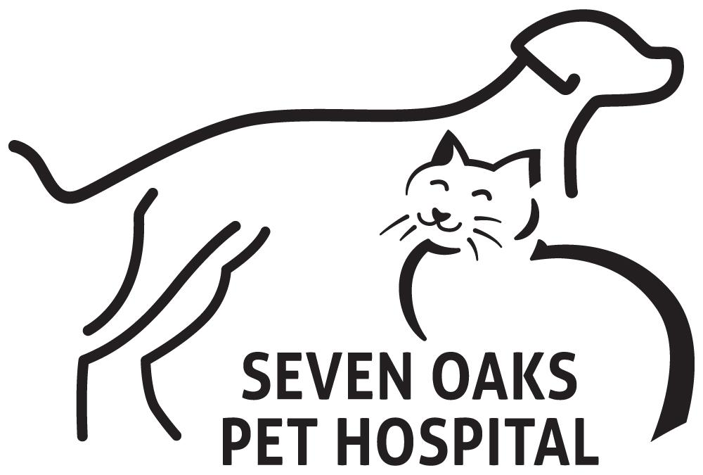

Dew claws are claws on a dog that grow farther up the leg than regular claws. They are usually on the back of the leg and appear more often on front legs than back legs. They do not make contact with the ground when the dog is standing, though they make may contact with the ground when the dog is running.

In dogs where the dew claws never make contact with the ground, dew claws need to be trimmed, as they will not be worn down by ground contact like regular claws.

Some dew claws are not connected properly to the leg and may be loose or floppy. This type of dew claw is more likely to present a problem and in most cases will need to be surgically removed.

| **Double Dew Claws:**  Some dogs have two extra claws growing from the back of one or multiple legs. These dogs are said to have double dew claws. |
| --- |

**Removing Dew Claws: The Procedure**

Depending on the age of the dog, removing a dew claw is a simple procedure that may even be able to be done with only a local anesthetic, meaning the dog is not under total anesthesia and is only numbed at the removal site.

A dew claw should only be removed by a licensed veterinarian in an office setting. While it is a simple procedure, owners should not attempt dew claw removal on their own, as complications can occur and proper precautions should be taken.

Dog owners should plan on being with their dog during the recovery period, as dogs often will not stop licking the removal site.

**Removing Dew Claws: Combining Procedures**

In many cases, veterinarians can recommend dew claw removal at the same time a dog is spayed or neutered. This means the dog will only be under anesthesia once, and only one recovery period and veterinarian visit will be necessary.

This can be helpful for both owners and dogs: Owners will only need to plan their schedule around one vet visit and one recovery period, and dogs will only need to undergo anxiety of a vet visit and pain with recovery during one short period. Additionally, this will save dog owners money on office visit charges at the veterinarian.