**Entropion and Ectropion Eye Surgery** 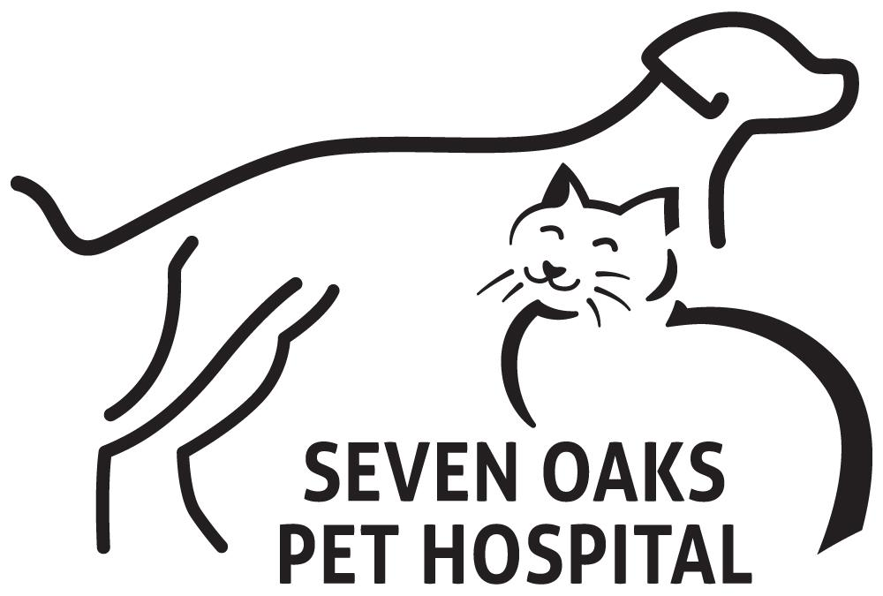

**Entropion and Ectropion in dogs** (Eyelids that roll inward or outward in dogs)

**Entropion** is a congenital condition that involves eyelids that roll inward against the cornea of the eye.

**Ectropion** is the opposite, the eyelid droops outward.

Entropion and ectropion are conditions that involve the eyelids. With an entropion the eyelids roll inward and rub against the cornea of the eye. This can cause a great deal of discomfort for the dog. Ectropion is the opposite of entropion, the eyelids droop exposing the cornea. These conditions are more common in dogs then cats. Entropion can be a congenital defect but can also occur following trauma, painful corneal lesions, and conjunctival inflammation. Ectropion is considered normal in some breeds but can also develop in senile dogs that lose muscle tone and can also be seen in dogs that had an entropion over corrected.

**Predisposed Breeds: Entropion -** Breeds that are commonly seen with entropion include but are not limited to; Chow Chow, Chinese Shar-Pei, Irish Setter, Golden Retriever, Labrador Retriever, Collie, Great Dane, and Rottweiller.

**Ectropion -** Dog breeds that include ectropion as a breed characteristic include but are not limited to; Basset Hound, Bloodhound, Cocker Spaniel, Cumber Spaniel, Bulldog, and Saint Bernard.

**Symptoms: Entropion**

* Eyelids appear to roll inward.
* Excessive tearing.
* Winking.
* Conjunctivitis - eyes will appear red or inflamed.
* Pain. Painful eyes cause dogs to paw and rub their eyes resulting in more damage.
* Sensitivity to light.

**Symptoms: Ectropion**

* Eyelids appear to roll outward exposing the eye.
* Conjunctivitis - eyes will appear red or inflamed.
* Excessive tearing.
* Inflammation of the cornea, due to exposure.
* Discharge from the eyes.

**Diagnosis:** A diagnosis should be done by a veterinarian. Veterinarian will do a complete exam on the eyes while the dog is awake, this will help prevent overcorrection or under-correction of the problem. If an overcorrection or an under-correction is the result then the dog may require further treatment. The doctor will pay careful attention to the placement of eyelashes and if/where they may rub on the eye. The doctor will also need to check the eye for further damage caused by the defect. This is generally done by using fluorescein dye to stain the eye. This stain will expose ulcers in the the cornea of the eye alerting the doctor that damage has been done to the cornea and treatment is necessary.

**Treatment:** Treatment is always surgical.

* Entropion - Many times the surgery to repair an entropion involves removing an elliptical piece of tissue directly under the eye, the two sides are sutured together pulling the affected eyelid down. Antibiotic eye drops or ointments may be sent home following the procedure..
* Ectropion - The technique involves a "V" or "Y" incision to shorten the lid.

## **After the Surgery:**

After a dog undergoes entropion surgery, he is sent home with an Elizabethan collar around his neck. This collar will prevent him from scratching the surgical stitches. This collar is worn at all times until the stitches are removed. Also, topical antibiotics may be prescribed to prevent infection around the surgery site..

## **Prognosis:**

The success rate of entropion surgery varies based on breed, age, and case specifics. In general, entropion surgery is successful 90 to 95 percent of the time, and recurrence is very uncommon, unless the surgery involves extensive skin removal, such as in breeds like the Shar Pei. In this instance, several follow-up surgeries may be needed to completely correct the condition.